* Home Screen - shows the categories and their documents

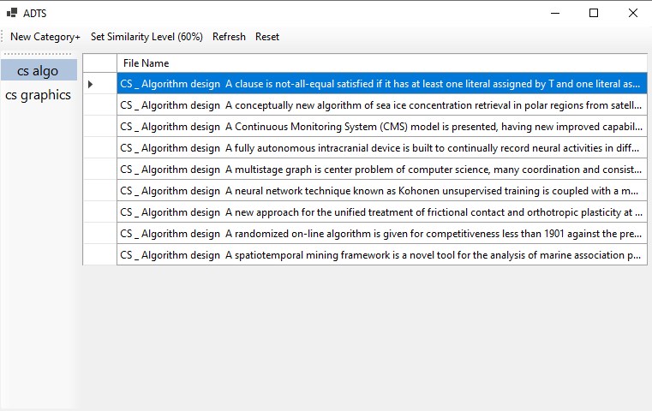

* On first run the system is empty, so is home screen
* The user can use the top bar to start adding categories
* Top Bar



* Adding Category - Category name, at least 1 file

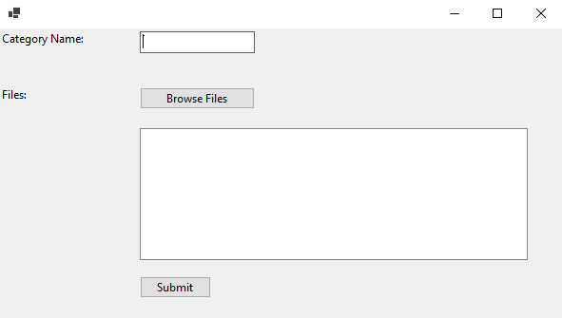

* Set similarity level – a number between 0 and 100

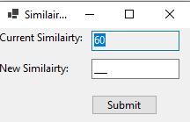

* Refresh – rescan the DBE to see if more documents were added and fit into any category
* Reset – clear the documents from DBI and reset the DB of salient words and notions
* Non Relevant - can assign documents that were classified as non relevant to a category

